
COHORT - 17

Employee Data Cleaning & Validation Using Microsoft Excel
Guided Hands-on Data Analytics Project WsCube Tech Data Analytics Program Prepared by: Rukaiyaa Shaikh
POINTS COVERED IN THIS PROJECT
- Introduction to Data Analytics
- Understanding Different Types of Data
- Data Collection and Data Preparation
- Excel Data Cleaning and Formatting
- Sorting Data
- Filtering Data
- Custom AutoFilter and Multiple Criteria Filtering
- Text to Columns – Delimited Method
- Text to Columns – Fixed Width Method
- Flash Fill for Data Transformation
- Find and Replace for Data Cleaning
- Handling NULL and N/A Values
- Identifying and Handling Blank Cells
- Removing Duplicate Records
- Data Validation – Age Restrictions
- Data Validation – Department Drop-down List
- Data Validation – Employment Status Drop-down List
- Conditional Formatting – Color Scales
- Conditional Formatting – Icon Sets
- Conditional Formatting – Data Bars
- Data Standardization and Consistency
- Practical Data Cleaning Using Microsoft Excel
- Documentation of Data Cleaning Steps with Evidence Screenshots

Project Objective

The objective of this project is to apply fundamental data analytics and Excel data-cleaning techniques to a deliberately messy employee dataset. The project focuses on identifying data-quality issues, cleaning and standardizing the data, applying validation rules, and documenting the transformation process.



Dataset
Dataset: Employee Data
Records: 120
Tool: Microsoft Excel

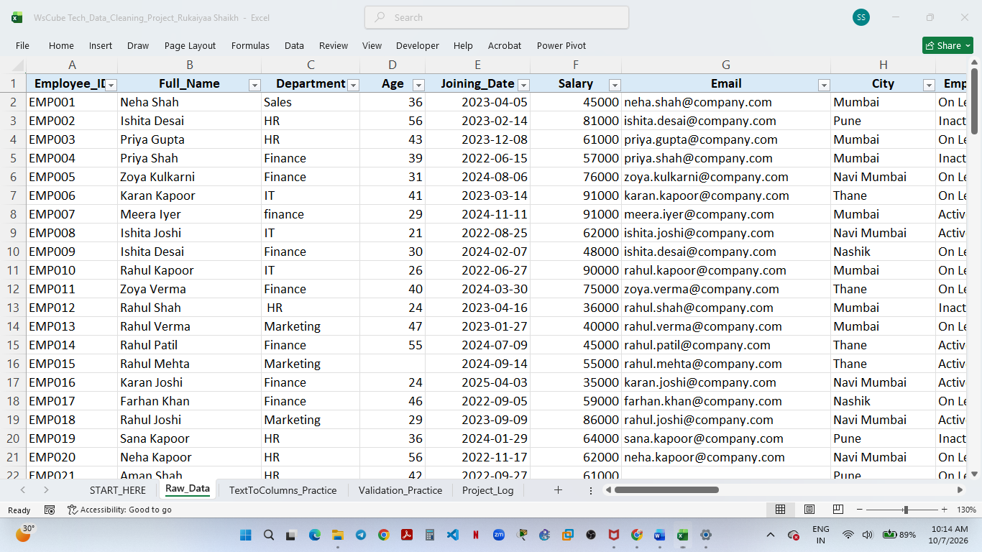
The raw dataset contains employee information including Employee ID, name, department, age, joining date, salary, email, city, employment status, performance score and phone number.

1. Sorting & Filtering

Sorting
Purpose:
To organize the dataset and identify specific records efficiently.
What I performed:
I used the Sort feature to arrange employee records based on Salary from smallest to largest. The “My data has headers” option was enabled so that the column headings were excluded from the sort.
I also used the Sort feature to arrange Employee names alphabetically from A to Z. The complete employee records were sorted together to maintain the relationship between each employee and their corresponding information.

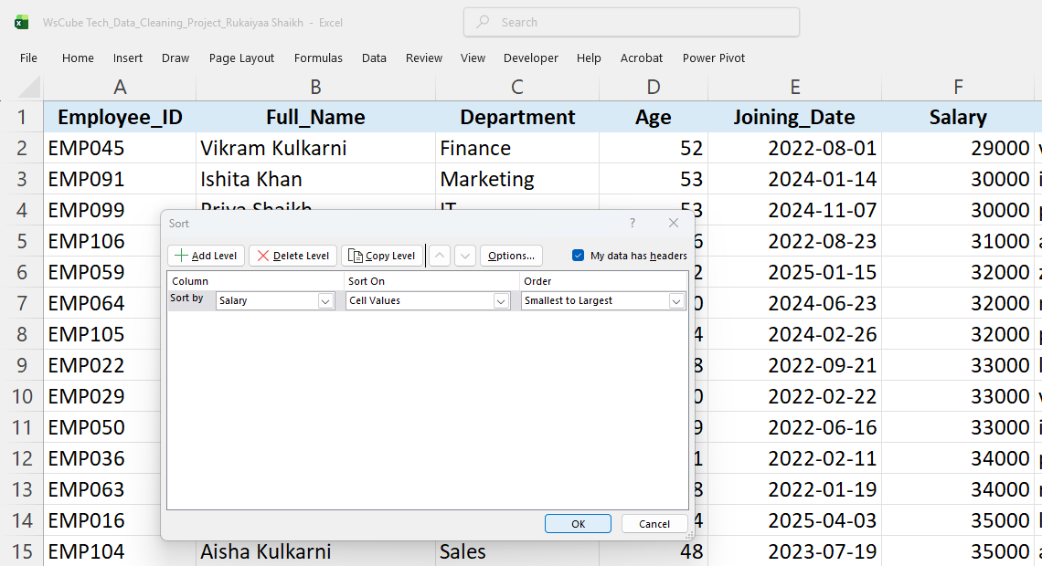
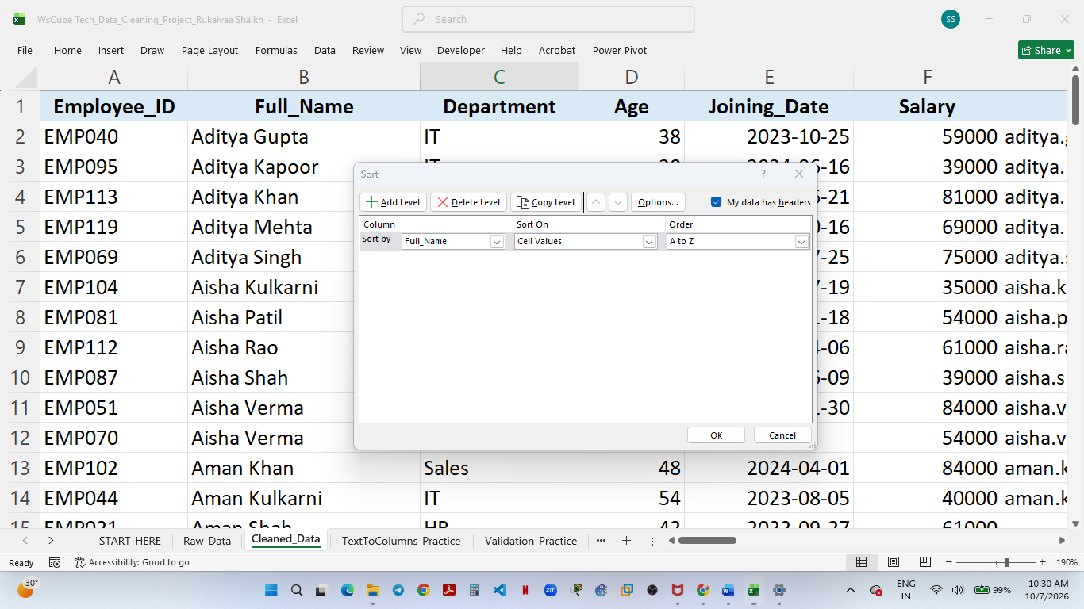

Filtering — Department
Purpose:
To display only records that meet a specific condition.
What I performed:
I applied a filter to the Department column and selected Finance. The dataset was filtered to display only employees belonging to the Finance department.
Result:
33 of 120 records matched the Finance filter.
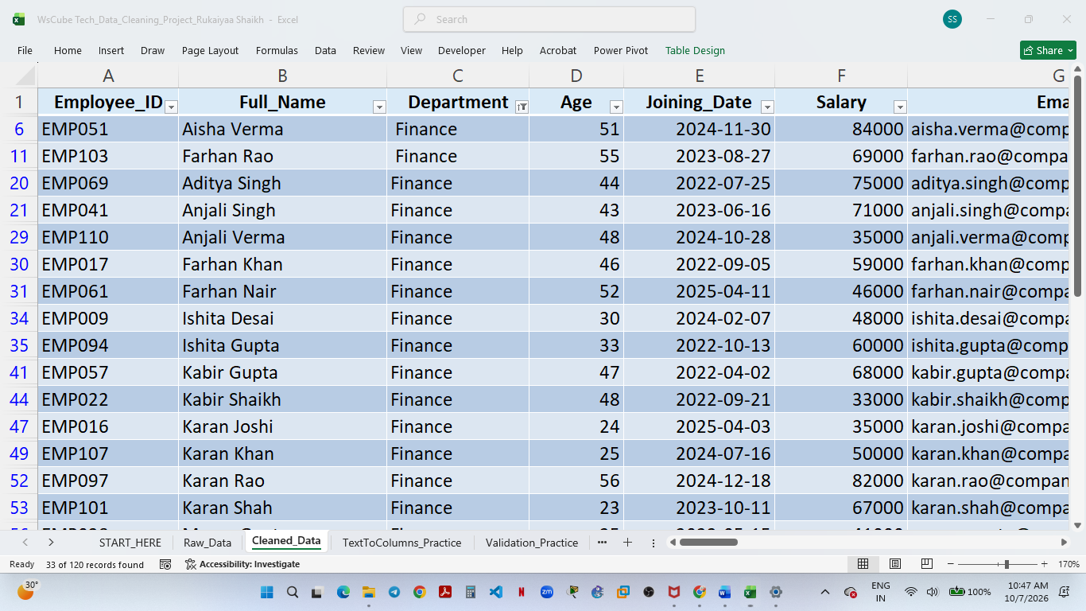

Filtering — Multiple Values
What I performed:
I applied a filter to the Department column and selected multiple values, Finance and IT, to display records belonging to either department.
Result:
The filter displayed 53 of 120 records matching the selected departments.
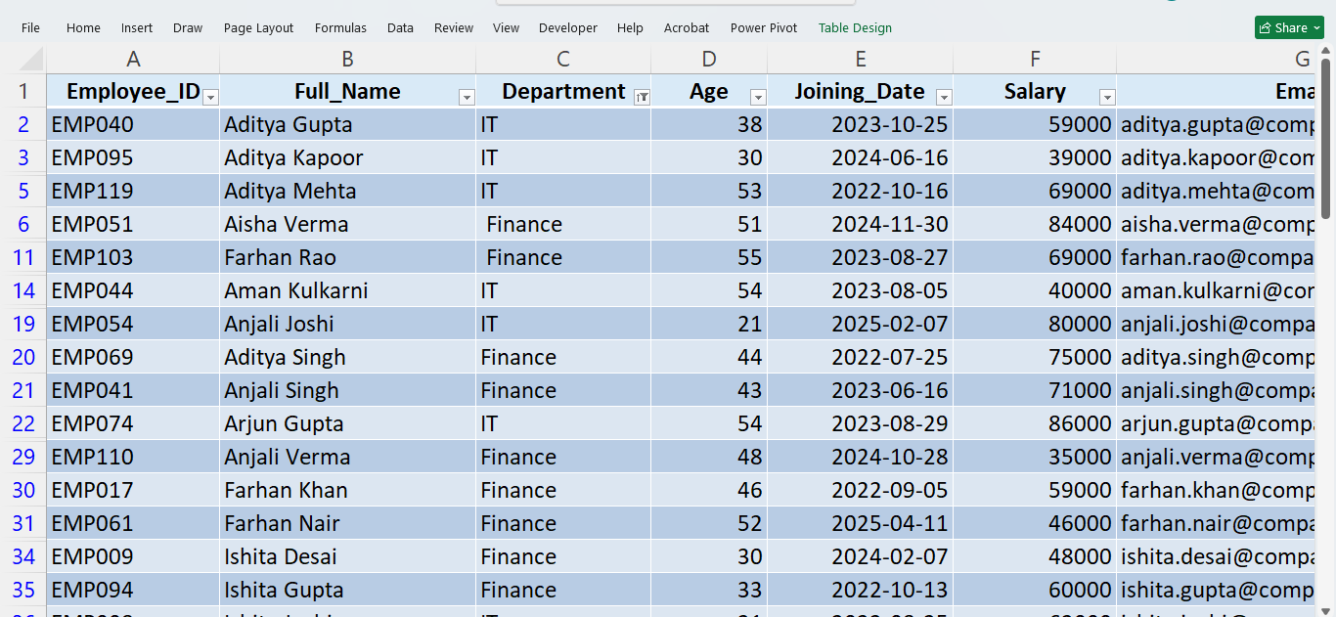

Filtering — Number Filter
I used the Number Filters option on the Salary column and applied the condition “is greater than 70,000.” This displayed only employees whose salary exceeded ₹70,000.
A total of 48 out of 120 records met the condition.

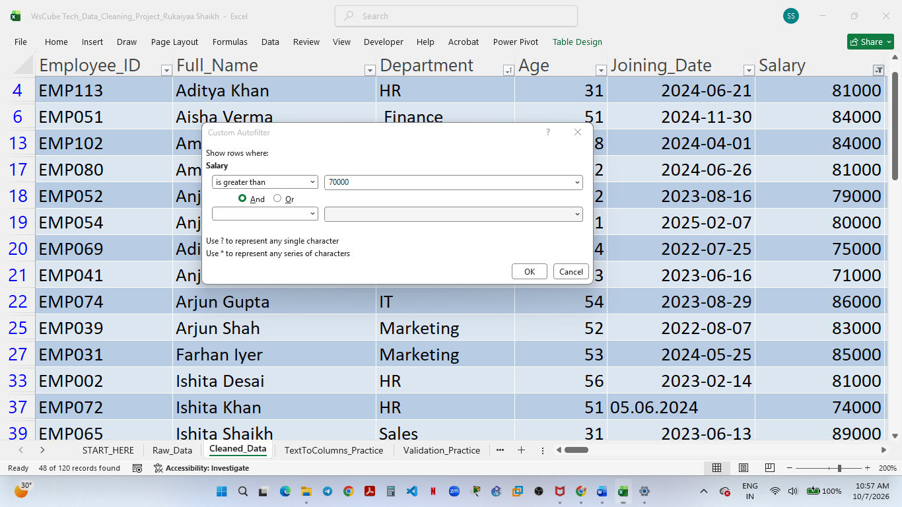

Filtering — Date Filter
What I performed:
I applied a Date Filter to the Joining_Date column using the condition “is after 01-Jan-2024.”
Result:
48 of 120 records matched the condition.
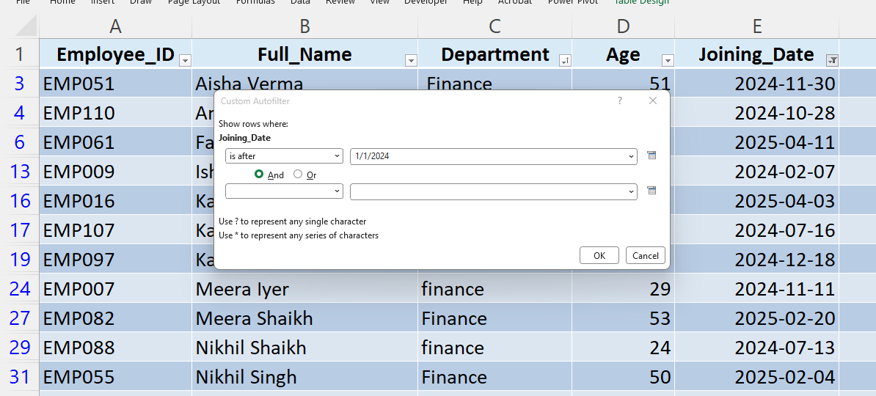

Filtering — Text Filter
What I performed:
I applied a Text Filter to the Full_Name column using the “contains” condition and entered “Khan”.
Result:
The filter identified 9 of 120 records where the employee's name contains "Khan".

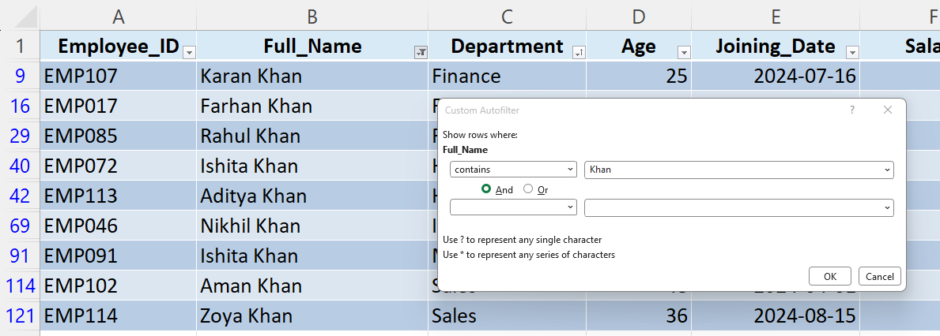

Text to Columns — Delimited
Purpose:
To split data from a single column into multiple columns using a specified delimiter.
What I performed:
I used Data → Text to Columns → Delimited and selected Comma (,) as the delimiter. The comma-separated values were divided into separate columns.
Example:
Riya, Shah, HR, Mumbai → Riya | Shah | HR | Mumbai
Result:
The original combined text was successfully separated into four individual fields.
Learning:
The Delimited option is useful when data fields are separated by a specific character such as a comma, tab, semicolon, space, or another custom delimiter.

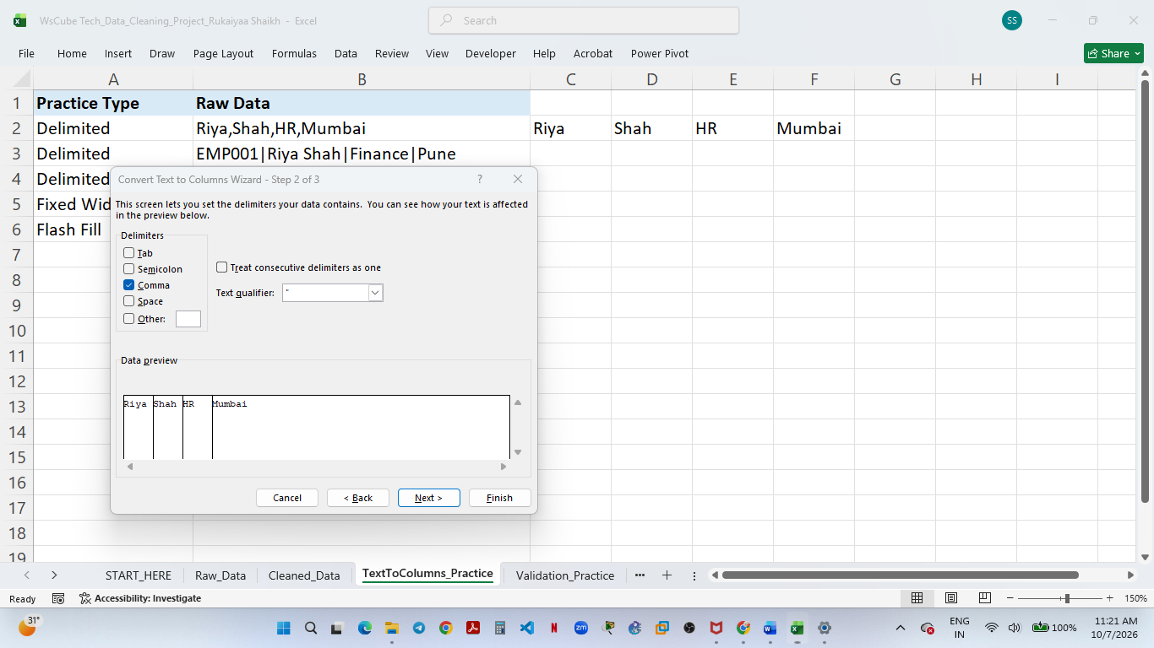

Text to Columns — Other / Custom Delimiter
What I performed:
I selected Delimited → Other and entered the pipe symbol | as a custom delimiter.
Example:
EMP001|Riya Shah|Finance|Pune → EMP001 | Riya Shah | Finance | Pune
Result:
The data was successfully separated into individual fields using a custom delimiter.
Learning:
The Other option allows a user to specify a delimiter that is not directly available in Excel's standard delimiter list.
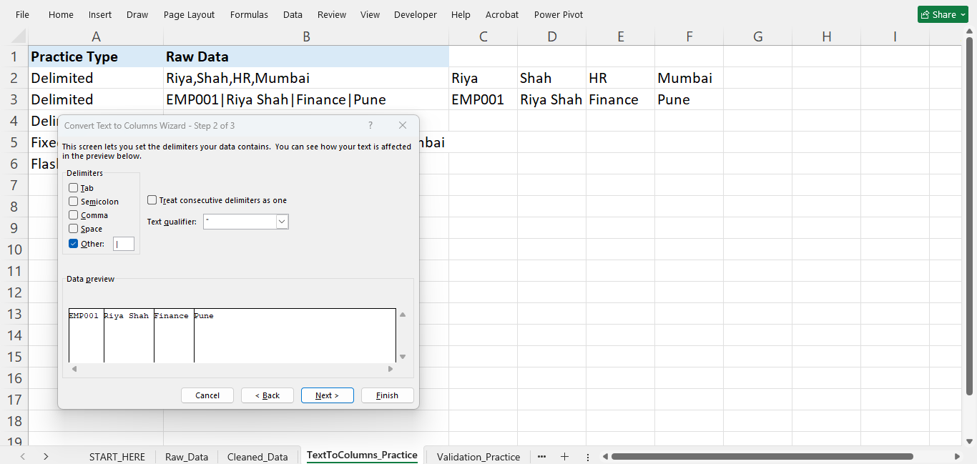

Text to Columns — Fixed Width
Purpose:
To split data into multiple columns based on fixed character positions rather than a delimiter.
What I performed:
I selected Text to Columns → Fixed Width and manually placed column break lines at the appropriate positions in the Data Preview.
Example:
EMP001 Riya Shah HR Mumbai
→ EMP001 | Riya | Shah | HR | Mumbai
Result:
The fixed-width record was successfully divided into five separate fields.
Learning:
Fixed Width is useful when data is arranged according to consistent character positions instead of being separated by a delimiter.

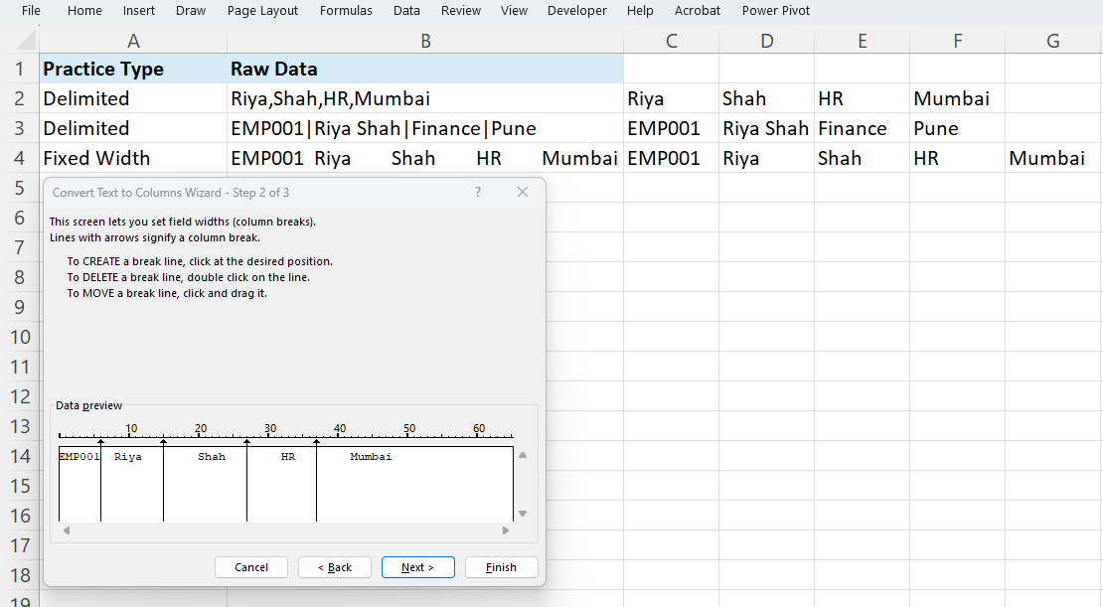

Flash Fill — Extracting First and Last Names

What I performed:
I used Flash Fill (Ctrl + E) to automatically extract the first name and last name from the Full_Name column. After providing the initial pattern, Excel recognized the pattern and populated the remaining records automatically.
Result:
First and last names were successfully separated without using formulas.
Learning:
Flash Fill is useful for pattern-based data transformation and can save time when working with consistently structured text.

Flash Fill — Practical Evidence
Then underneath:
Shortcut used: Ctrl + E
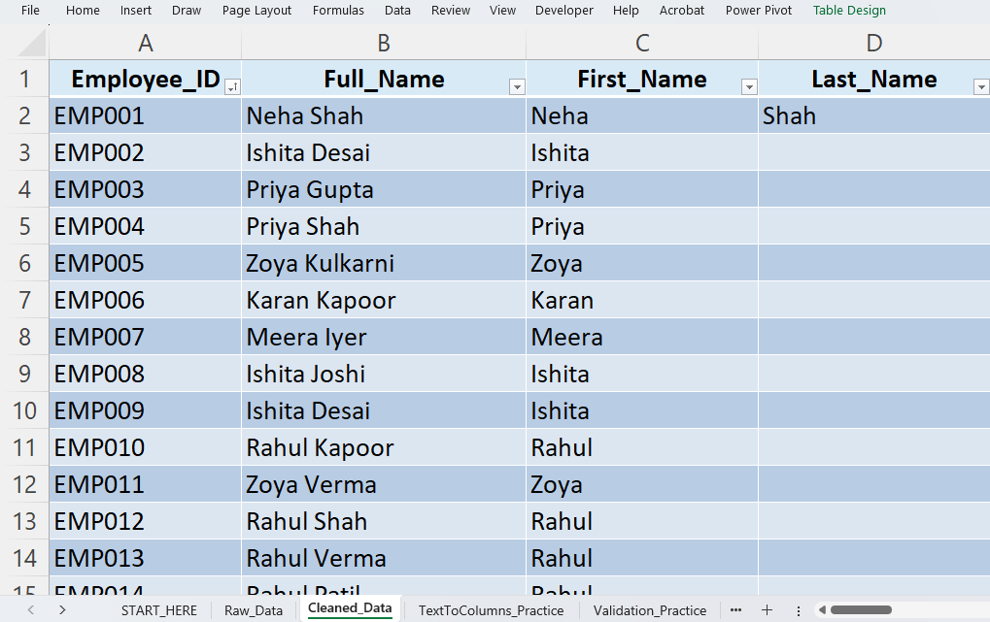

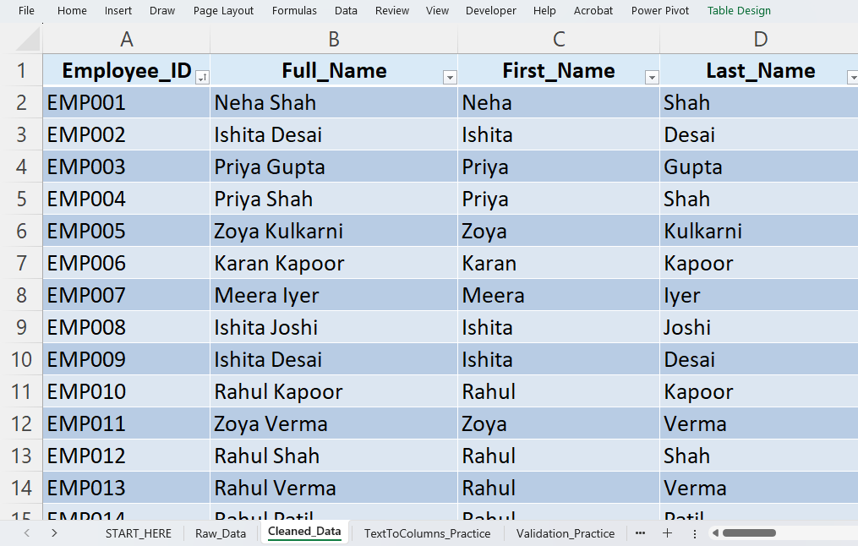

Missing & NULL Values — Identification
Purpose:
To identify missing or null values present in the employee dataset before deciding how they should be handled.
What I performed:
I used Find & Replace (Ctrl + H) to search for the value NULL in the dataset.
Result:
Excel identified 2 cells containing NULL values. One of the identified records is visible in the Email column.
Learning:
NULL values represent unavailable or missing information and should be identified before performing further data analysis or validation.

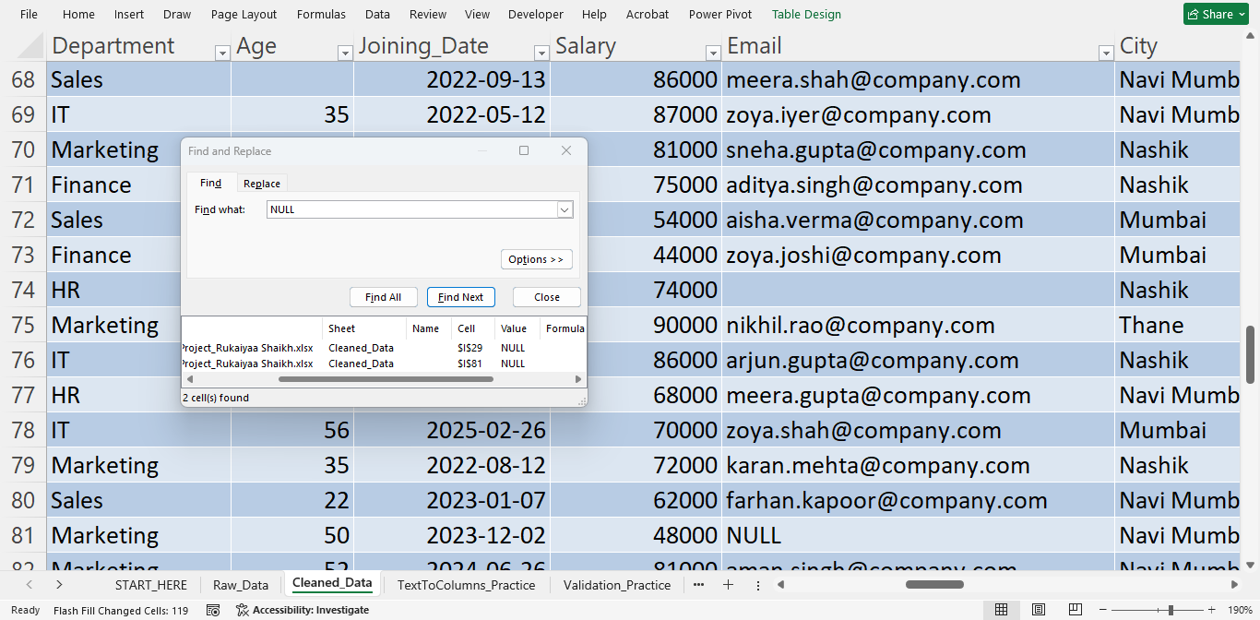

Missing & NULL Values — N/A Identification
What I performed:
I used Find & Replace (Ctrl + H) to search for the value N/A in the dataset.
Result:
Excel identified 1 cell containing N/A in the Salary field.
Learning:
N/A is an explicit placeholder indicating that a value is not available. It should be identified and handled appropriately before analysis.

Evidence:

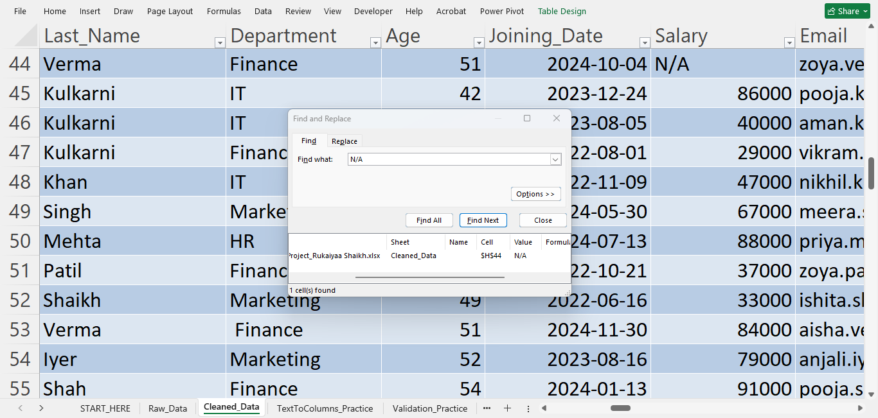

Missing & NULL Values — Blank Cell Identification
What I performed:
I used Go To Special → Blanks to identify genuinely empty cells in the dataset.
Result:
Excel identified 4 blank cells.
Learning:
Blank cells are different from text values such as NULL or N/A. Identifying the type of missing value is important before deciding how it should be handled.
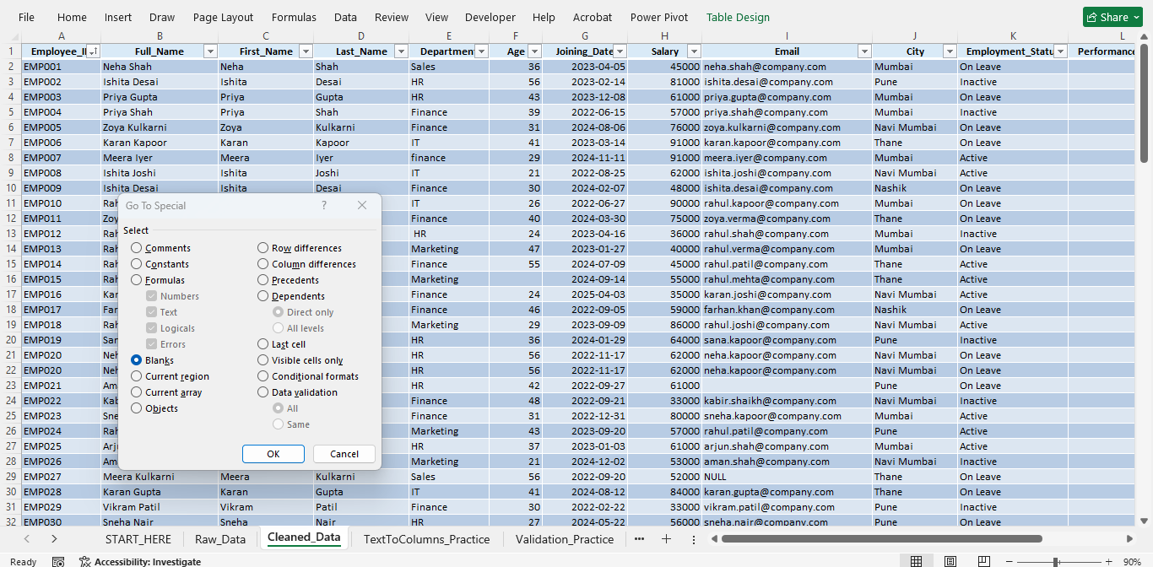

NULL Values — Identification

I used Find & Replace (Ctrl + H) to search for NULL values in the Cleaned_Data sheet. Excel identified 2 cells containing NULL. One of the identified records is visible in the Email column.

NULL Values — Standardization

The identified NULL values were replaced with N/A using Find & Replace (Ctrl + H). This standardized the missing Email values into a consistent representation.

Learning

NULL is different from a genuinely blank cell. Before cleaning the data, I first identified the type of missing value and then applied an appropriate standardization method.

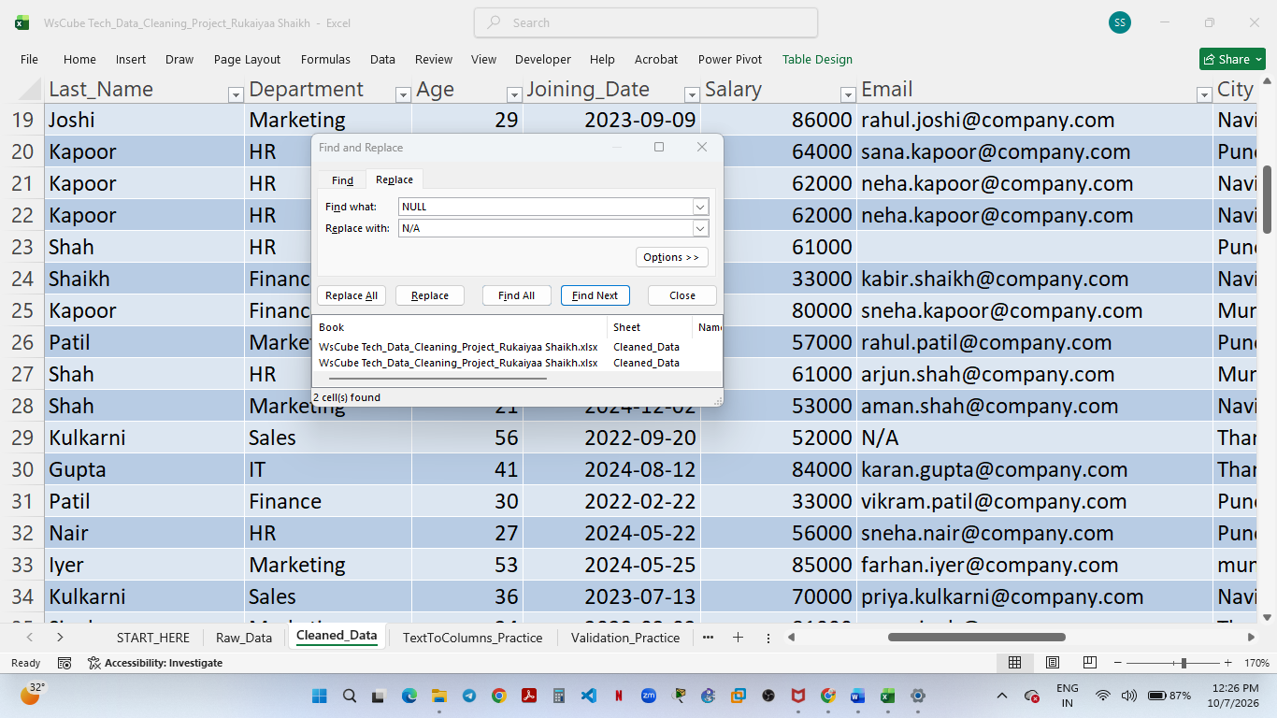

Blank Values — Age Field
What I performed:
I used Go To Special → Blanks to identify genuinely missing values in the Age field.
Result:
Two employee records were identified with blank Age values: EMP015 and EMP066.
Data-cleaning decision:
Since Age is a numeric field, the missing values were retained as blanks rather than replacing them with text such as N/A, which could affect numerical analysis.
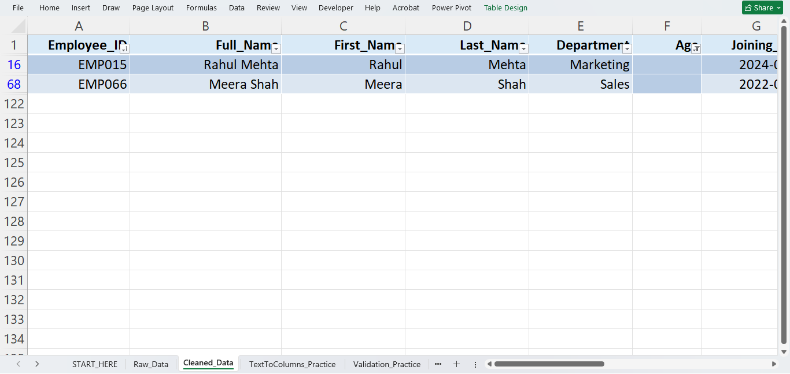

Blank Email Values — Identification
I filtered the Email column for blank values and identified 2 records with missing Email IDs. The missing Email values were subsequently standardized as N/A.
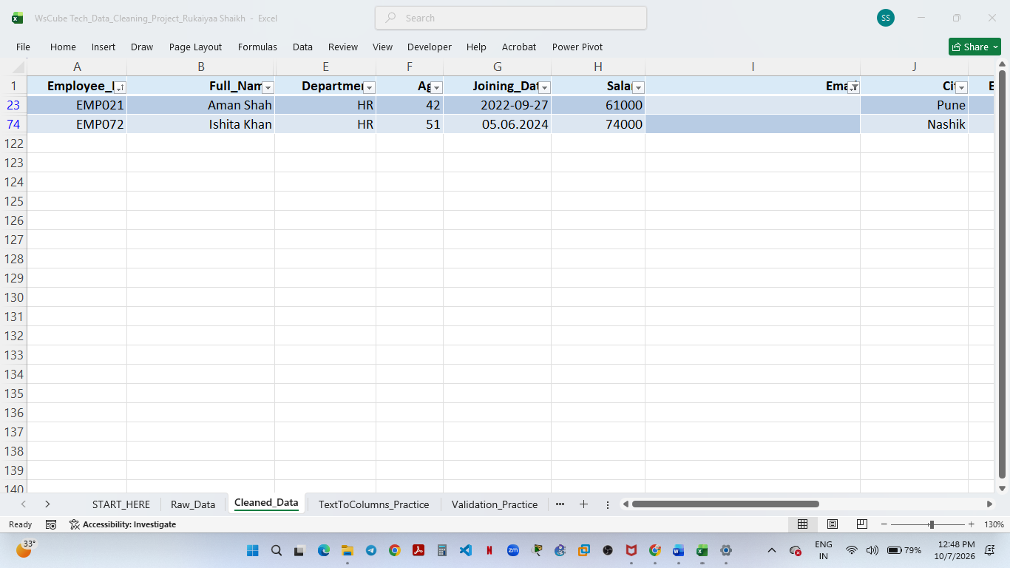

Duplicate Values — Employee ID
What I performed:
I used Data → Remove Duplicates and selected Employee_ID as the unique identifier.
Purpose:
Employee IDs should be unique for each employee. Duplicate Employee IDs can indicate repeated records and may lead to inaccurate analysis.
Result:
Excel identified and removed duplicate Employee ID records.

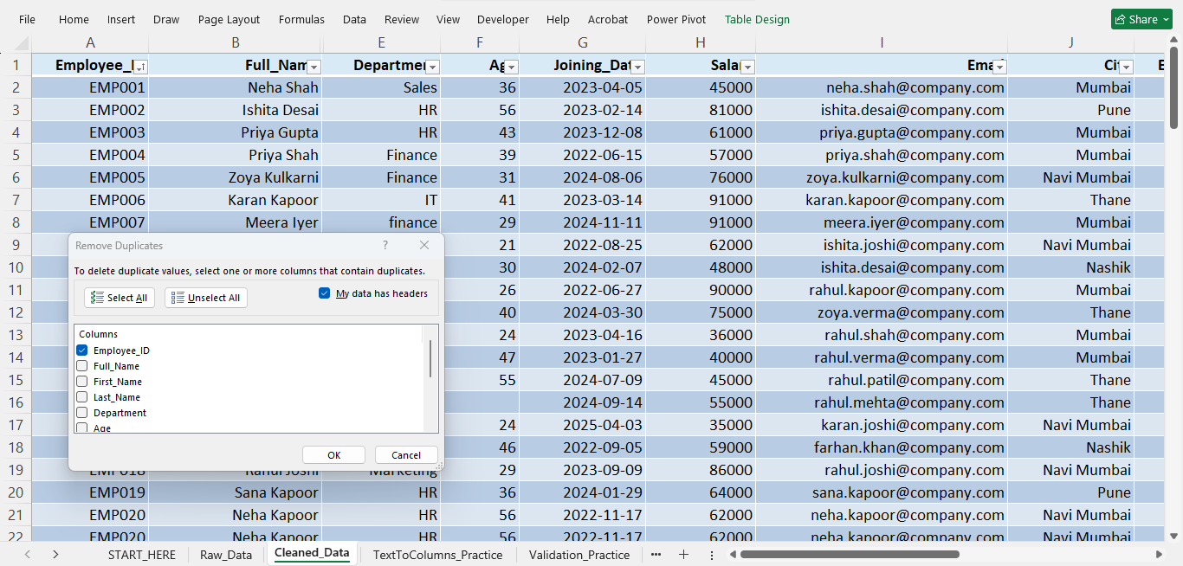

Duplicate Values — Removal Result
Action performed:
I used Data → Remove Duplicates and selected Employee_ID as the unique identifier.
Result:
Excel identified 1 duplicate Employee ID and removed the duplicate record. The dataset now contains 119 unique Employee IDs.
Learning:
Employee ID should be unique for each employee. Removing duplicate IDs helps prevent repeated records from affecting analysis and reporting.

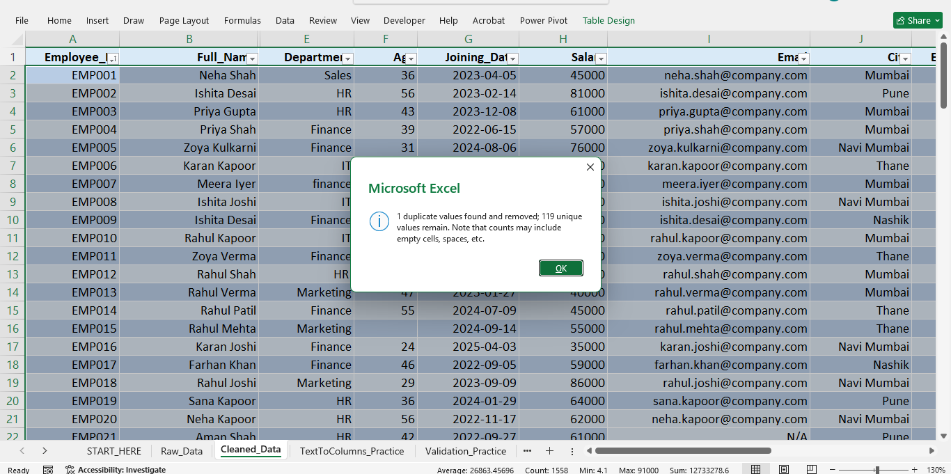

Conditional Formatting — Greater Than
I applied Conditional Formatting using the Greater Than rule to identify employees with a salary greater than ₹70,000. Values above ₹70,000 are automatically highlighted, making higher salary values easier to identify and compare.
Rule applied: Salary > 70,000
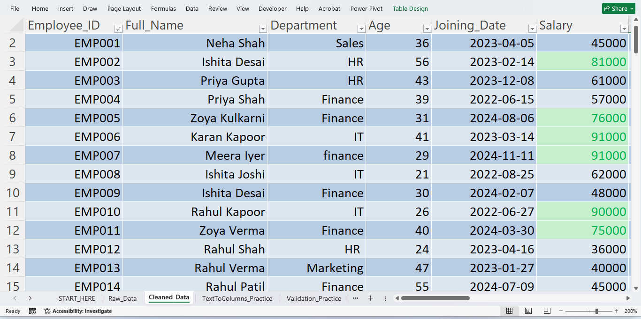

Conditional Formatting — Less Than
I applied Conditional Formatting using the Less Than rule to identify employees younger than 30 years. This makes younger employee records easier to identify during data analysis.
Rule applied: Age < 30
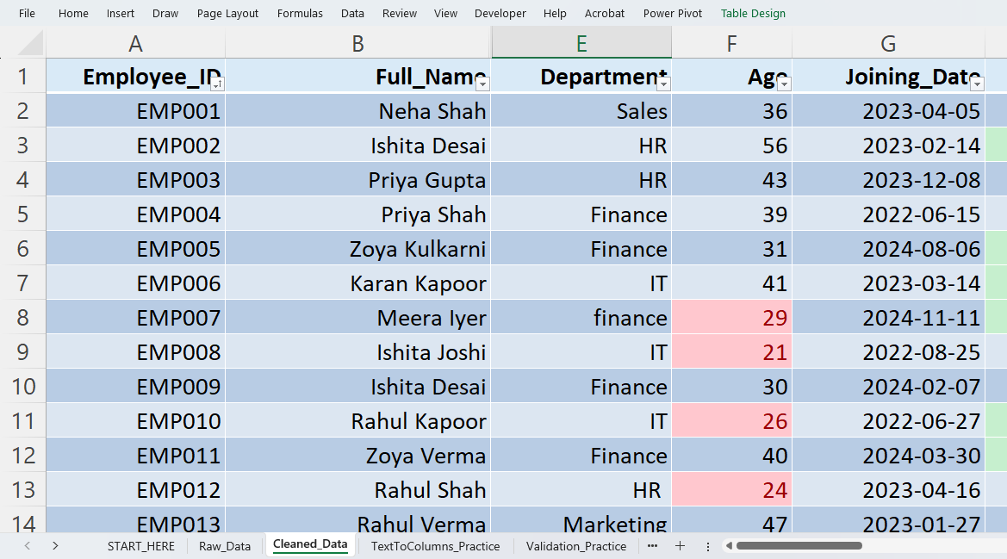

Conditional Formatting — Between
I applied Conditional Formatting using the Between rule to identify employees whose salary falls between ₹50,000 and ₹80,000. This helps quickly identify employees within a selected salary range.
Rule applied: ₹50,000 ≤ Salary ≤ ₹80,000
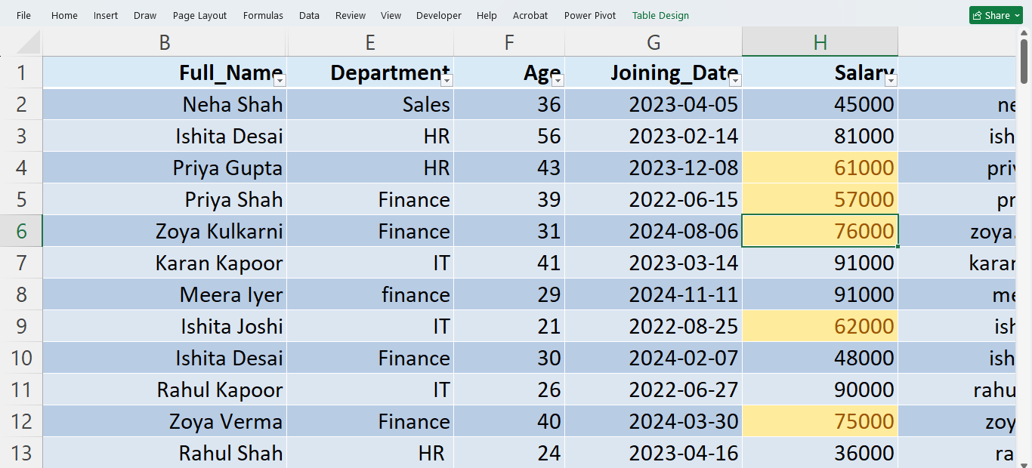

Conditional Formatting — Duplicate Values
I applied Conditional Formatting using the Duplicate Values rule to identify repeated employee names in the Full_Name column. The duplicate entries were highlighted for easy identification without deleting or modifying the original data.
Purpose: To quickly identify duplicate records that may require further data validation.
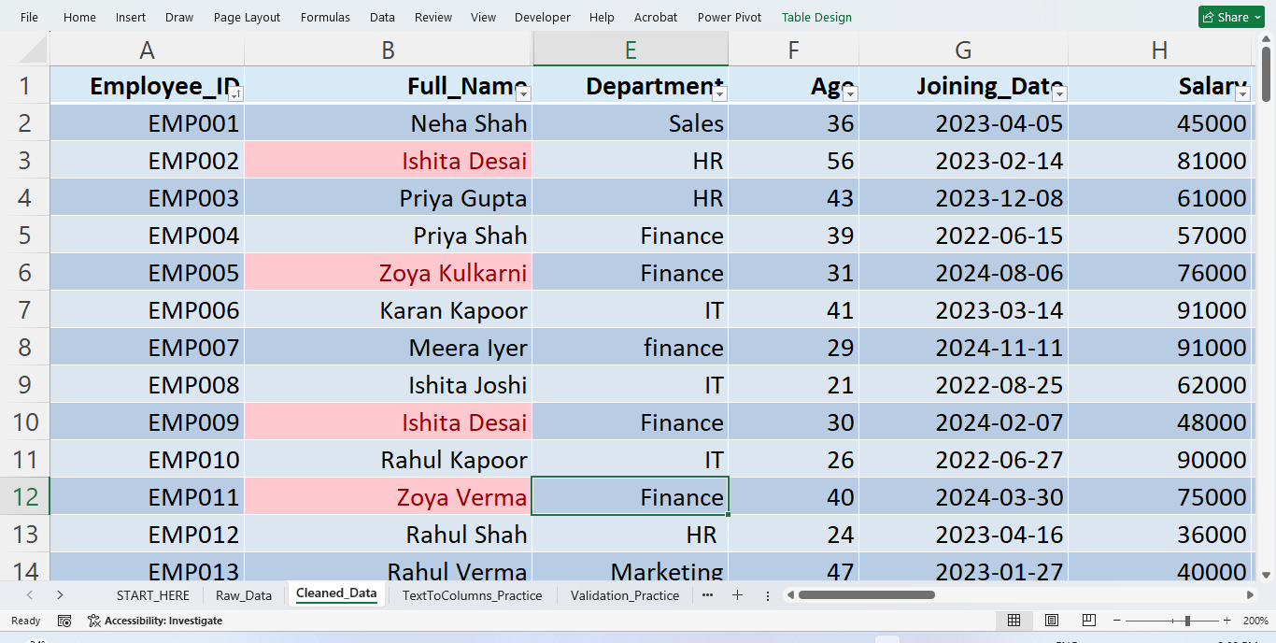

Data Validation – Age Restriction
Applied Data Validation to restrict employee age to whole numbers between 18 and 60. A test value of 11 was entered, and Excel successfully rejected the invalid entry, confirming that the validation rule is working correctly.
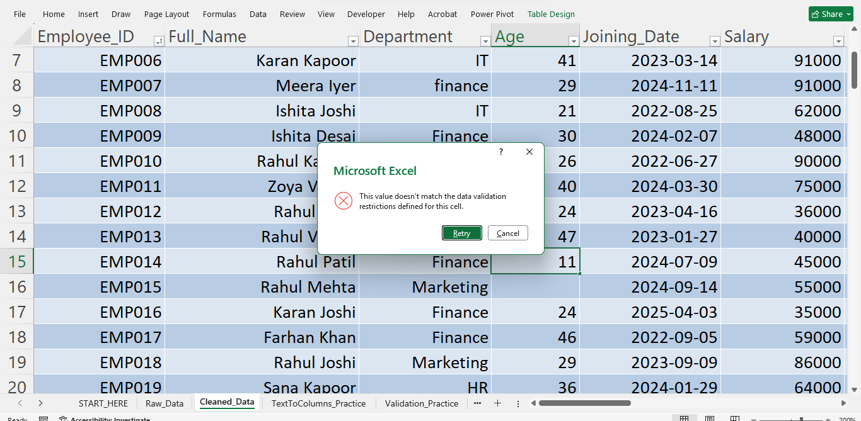
Data Validation – Department: Created a drop-down list containing standardized department names (HR, Finance, IT, Marketing, and Sales) to maintain consistency and reduce data-entry errors.
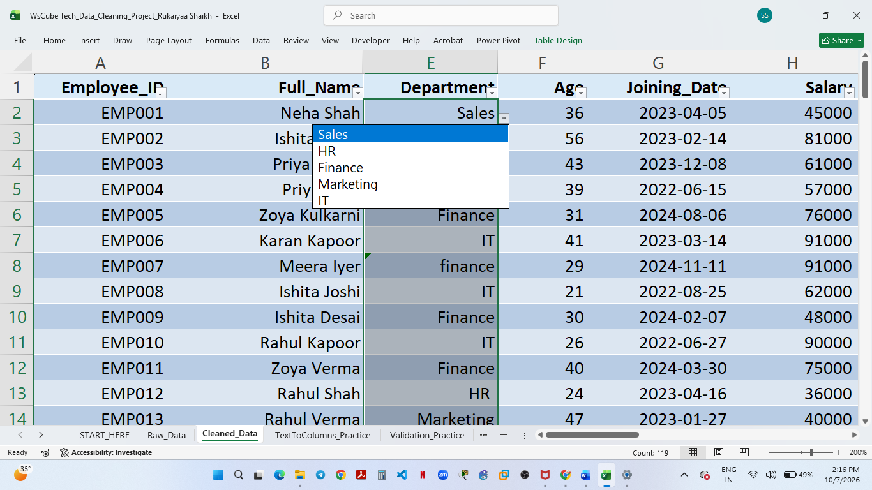

Data Validation – Employment Status:
Created a drop-down list containing Active, Inactive, and On Leave to standardize employment status entries and reduce data-entry errors.
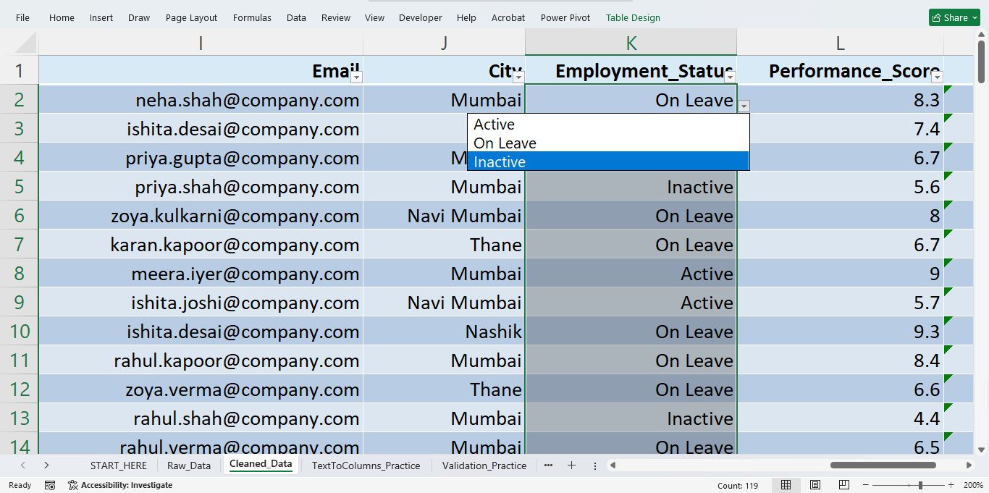

Conditional Formatting – Color Scale:
Applied a three-color scale to the Salary column to visually compare employee salary values and identify relatively low, medium, and high salary ranges.
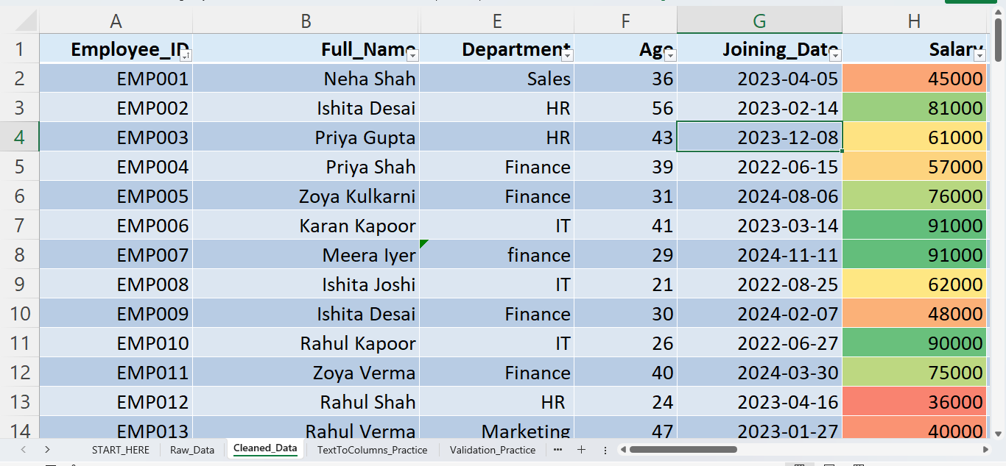

Conditional Formatting – Icon Set
Applied a three-arrow icon set to the Performance Score column to visually categorize employee performance levels and make performance differences easier to identify.
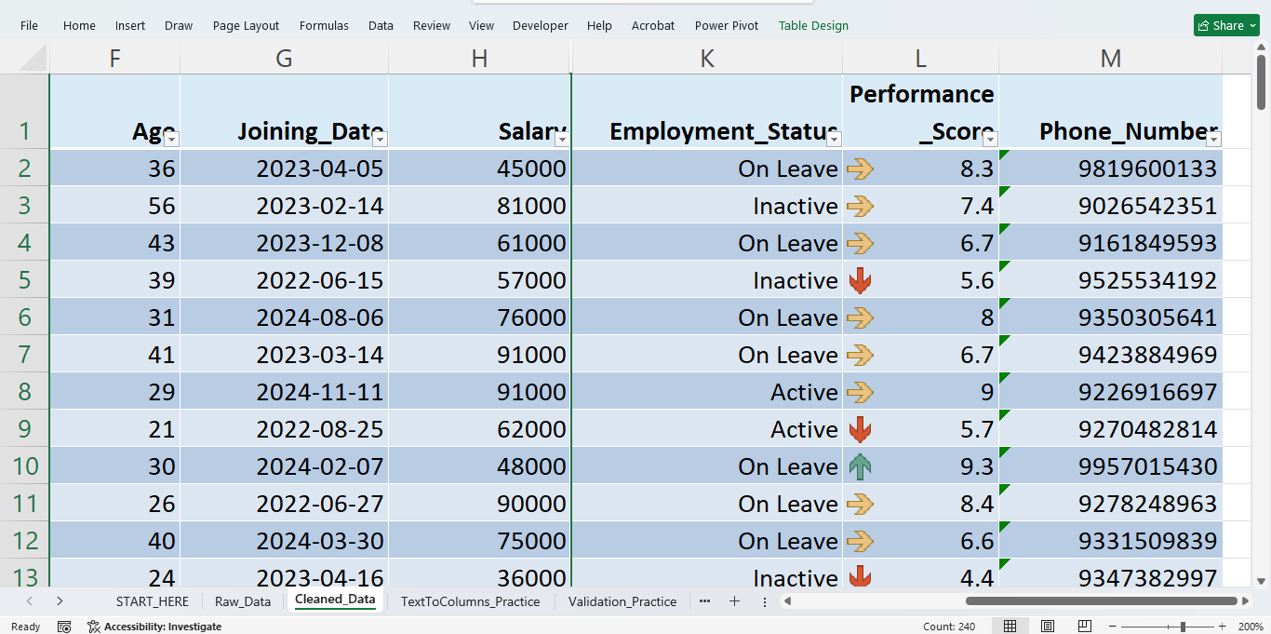
Conditional Formatting – Data Bars:
Applied data bars to the Age column to visually compare employee ages. The length of each bar represents the relative age value.
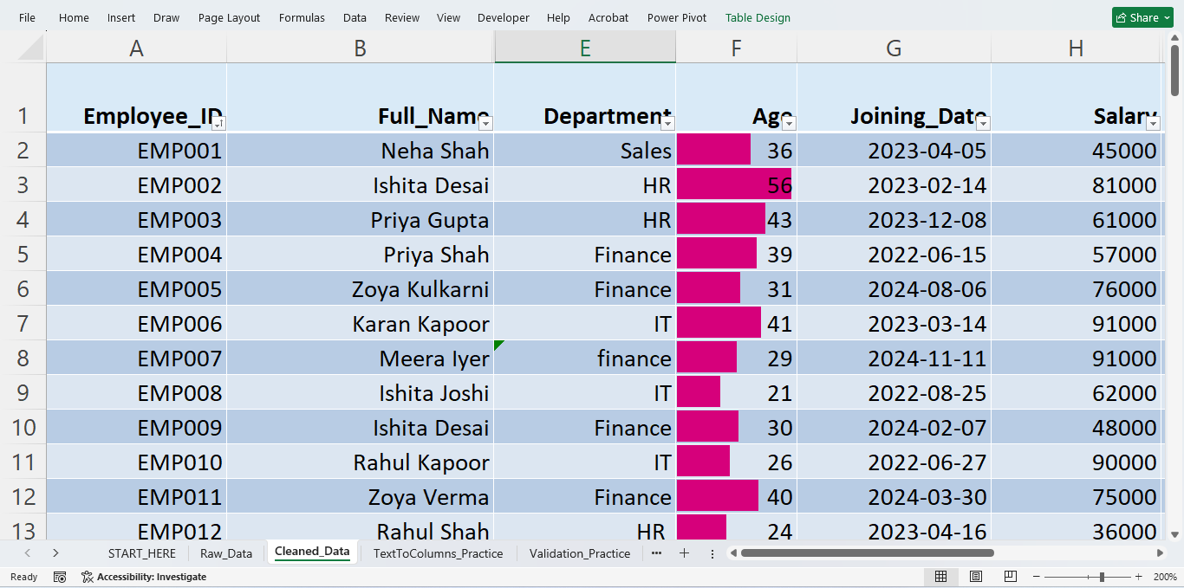

PROJECT OUTCOME
The employee dataset was systematically cleaned, standardized, validated and visually analyzed using Microsoft Excel. The project covered sorting, filtering, text transformation, missing-value identification, duplicate removal, data validation and conditional formatting. The final dataset contains standardized employee information with improved consistency and data quality, making it more suitable for analysis and reporting.



Data Quality Issue | Before | Action | After
Employee IDs | 120 | Remove Duplicates | 119 unique IDs  1 duplicate found
NULL Email | 2 | Standardized | N/A
N/A Salary | 1 | Identified | Documented
Blank Age | 2 | Retained as blank | Numeric integrity maintained
Department | Inconsistent case | Validation/dropdown | Standardized
Employment Status | Potential inconsistent entry | Dropdown | Standardized
Before vs After summary

